# Run Collection using Newman

newman run customer_io_WebPortal.postman_collection.json -e customer_io_webportal.postman_environment.json --insecure --reporters htmlextra <Filepath>

OR

newman run customer_io_WebPortal.postman_collection.json -e customer_io_webportal.postman_environment.json --insecure --reporters htmlextra <Filepath>

OR

newman run customer_io_WebPortal.postman_collection.json --timeout-script 300000 --environment customer_io_webportal.postman_environment.json --insecure --disable-unicode --reporters htmlextra <Filepath> json,cli,junit --suppress-exit-code

# Run Collection using Postman

1. Download Postman from <https://www.postman.com/downloads/> the .exe is dependent on if you are using a 32bit or 64bit pc.

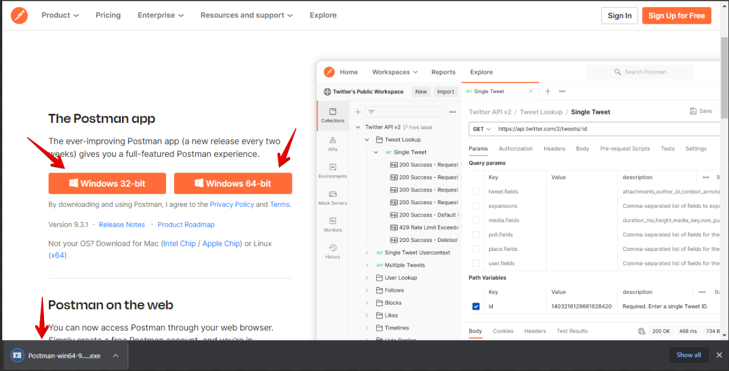

1. Create a Postman account.
2. When you log into Postman, click to import the “customer_io_WebPortal.postman_collection.json” and “customer_io_webportal.postman_environment.json” shared via GitHub

